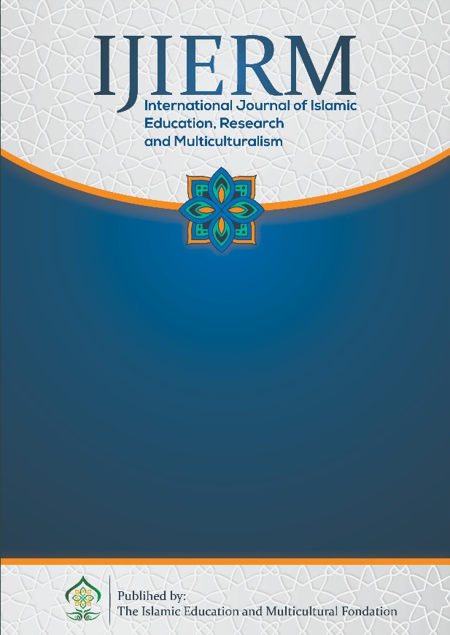 | International Jurnal Islamic Education, Research and Multiclturalism  (IJIERM)  Available online https://journal.yaspim.org/index.php/IJIERM/index

ADAPTIVE TEACHER DISCIPLINE IN THE DISRUPTIVE ERA: A CONCEPTUAL FRAMEWORK FOR JUNIOR HIGH SCHOOLS

Murniati¹, Siti Zuraida Duha², Afifah Nur Hidayah³
^{1,2,3} University Islam Syekh Yusuf (UNIS), Indonesia,
¹ Email: murniatitello@gmail.com

Abstrak
Era disrupsi secara fundamental menantang model disiplin guru tradisional yang berfokus pada kepatuhan, menciptakan kesenjangan signifikan antara praktik konvensional dan kebutuhan holistik pembelajar abad ke-21. Studi konseptual ini bertujuan mengatasi kesenjangan tersebut dengan merumuskan kerangka kerja konseptual adaptif yang terintegrasi untuk disiplin guru di Sekolah Menengah Pertama. Dengan menggunakan metodologi tinjauan integratif (integrative review), penelitian ini secara sistematis menganalisis dan mensintesis literatur ilmiah terkait profesionalisme guru, inovasi pedagogis, pembelajaran sosial-emosional, dan etika digital melalui analisis tematik. Hasil utamanya adalah Model Disiplin Guru Adaptif, sebuah kerangka konseptual baru yang terstruktur berdasarkan empat dimensi yang saling terhubung: Profesional-Adaptif, Pedagogis-Inovatif, Relasional-Empatis, dan Digital-Etis. Model ini diklaim sebagai arsitektur holistik yang melampaui manajemen kelas konvensional, menawarkan basis teoritis baru bagi profesionalisme guru. Ini memberikan implikasi praktis untuk reformasi pengembangan guru, kebijakan sekolah, dan strategi pendidikan di era disrupsi.
Kata Kunci: Disiplin Guru Adaptif; Kerangka Kerja Konseptual; Tinjauan Integratif; Sekolah Menengah Pertama (SMP); Era Disrupsi.

Abstract
The disruptive era fundamentally challenges traditional, compliance-focused teacher discipline models, creating a significant gap between conventional practices and the holistic needs of 21st-century learners. This conceptual study addresses this gap by aiming to formulate an integrated, adaptive conceptual framework for teacher discipline in Junior High Schools. Employing an integrative review methodology, the study systematically analyzed and synthesized scholarly literature related to teacher professionalism, pedagogical innovation, social-emotional learning, and digital ethics through thematic analysis. The main result is the Adaptive Teacher Discipline Model, a novel conceptual framework structured around four interconnected dimensions: Professional-Adaptive, Pedagogical-Innovative, Relational-Empathetic, and Digital-Ethical. This model is argued to be a holistic architecture that transcends conventional classroom management, offering a new theoretical basis for teacher professionalism. It provides practical implications for reforming teacher development, school policies, and educational strategies for the disruptive era.
Corresponding Author | Murniati
Article History | Submitted: 3 September 2025 | Accepted: 20 October 2025 | Published: 28 October 2025

Keywords: Adaptive Teacher Discipline; Conceptual Framework; Integrative Review; Junior High Schools; Disruptive Era.

INTRODUCTION
Education in the 21st century is experiencing a fundamental transformation driven by technological disruption and globalization, which demands a profound shift in the role of educators. Teachers are no longer the sole source of knowledge but must evolve into adaptive facilitators who are adept at integrating digital tools and innovative pedagogies to meet the needs of modern learners (Reistanti et al., 2025). This global phenomenon presents a significant social fact in the Indonesian context, where educational policy has strategically evolved to address these challenges. The transition from the 2013 Curriculum, which faced implementation hurdles, to the more flexible and responsive Kurikulum Merdeka (Independent Curriculum) reflects a national effort to create an educational system capable of thriving in the disruptive era (Biantoro & Jasmina, 2021; Waton, 2023). This policy shift underscores the urgent need for a corresponding evolution in teacher practice to ensure its successful implementation and the achievement of desired learning outcomes.
A critical review of global literature reveals that conventional, behaviorist-rooted classroom management strategies are fundamentally disconnected from the unique characteristics of Generation Z students as digital natives (Pavlíčková et al., 2024; Prasetyarini et al., 2021). While research in Asia (Gondwe, 2021) and Europe (Zhou & Eslami, 2023) has highlighted the urgent need for teachers to adopt digital-ethical practices and innovative pedagogy (Hegade & Shettar, 2022), these efforts often propose solutions in silos. For instance, models like TPACK effectively guide technology integration but remain silent on relational-empathetic disciplinary practice, while studies on student conduct management rarely account for the ethical complexities of social media use among students. Furthermore, research across various contexts, including those outside the Indonesian setting, lacks an integrated, holistic model that unifies the professional, pedagogical, relational, and digital-ethical dimensions of teacher discipline. This systematic gap—the absence of a single, integrated conceptual framework that simultaneously addresses these four essential, modern competencies—results in teachers relying on partial, unadaptable strategies that fall short of cultivating holistic student outcomes in the disruptive junior high environment.
The primary objective of this conceptual study is to address the aforementioned systematic research gap by proposing the Adaptive Teacher Discipline Model, a holistic and integrated conceptual framework specifically tailored for junior high school contexts in the disruptive era. To achieve this, the study critically evaluates conventional models and synthesizes the essential elements required for a relevant and effective disciplinary approach. We argue that enhancing student outcomes in this era requires cultivating a comprehensive form of teacher self-discipline, rather than merely refining isolated management techniques. The core novelty of this study is the development of this new theoretical architecture, which is the first to systematically synthesize the four crucial and often-separated dimensions of: Professional-Adaptive, Pedagogical-Innovative, Relational-Empathetic, and Digital-Ethical practice. By moving beyond a partial focus on technology or compliance, this integrated framework provides a robust theoretical foundation for reforming teacher development programs, educational policies, and overall strategies to align fully with the complex realities of contemporary education.
LITERATURE REVIEW
The 21st-century educational landscape, shaped by globalization and technological disruption, demands a fundamental redefinition of the teacher's role, shifting from a knowledge dispenser to an adaptive facilitator (Reistanti et al., 2025). This paradigm promotes a student-centered approach, necessitating that teacher competency extends beyond subject mastery to include the pedagogical application of digital tools (Meifauziah & Said, 2024). This shift is reflected in national policies, such as Indonesia's transition to the flexible Kurikulum Merdeka, which aims to create more adaptive learning environments (Waton, 2023). A core challenge in this new era is the disconnect between conventional discipline models and the characteristics of Generation Z students. These digital natives expect relevance, interactivity, and collaborative settings, rendering traditional, behaviorist-rooted strategies—which often prioritize compliance through external control—increasingly ineffective for fostering sustained engagement and intrinsic motivation (Pavlíčková et al., 2024; Prasetyarini et al., 2021). This failure impedes the development of crucial 21st-century skills and highlights the limitations of outdated classroom management techniques (Chun & Abdullah, 2022).
To justify the need for the Adaptive Teacher Discipline Model, a critical evaluation of established discipline frameworks is necessary. Assertive Discipline (AD), characterized by clear rules, positive reinforcement, and systematic consequences, remains influential globally. Its strength lies in its simplicity and consistency, providing clear boundaries (Canter, 2001). However, contemporary literature critiques AD for its unidirectional and control-oriented nature, often failing to address the underlying psychological and emotional needs of students (Aldrup et al., 2022). In the disruptive era, this compliance-focused approach is seen as counterproductive to fostering self-regulation and empathetic citizenship (Coutinho et al., 2019).
In contrast, Positive Behavior Interventions and Supports (PBIS) offers a tiered, proactive, and preventative framework aimed at improving social competence and academic achievement. PBIS is widely praised for its holistic and data-driven approach (Bradshaw et al., 2012). Nevertheless, PBIS often faces limitations in the rapidly evolving digital context, primarily focusing on in-person classroom behaviors and lacking a comprehensive framework for ethical digital engagement and the complexity of online interactions (Tzoneva, 2023). Furthermore, while models like Technological Pedagogical Content Knowledge (TPACK) guide technology use (Hegade & Shettar, 2022), they remain focused on instruction rather than the integrated disciplinary approach required in the modern classroom.
This critical analysis reveals a significant research gap: no single existing framework systematically integrates the essential dimensions of adaptive professionalism, innovative pedagogy, relational-empathy, and digital ethics into a coherent model of teacher discipline (Gondwe, 2021; Zhou & Eslami, 2023). Previous studies have proposed partial solutions, but the absence of this unified theoretical architecture prevents teachers from achieving the holistic readiness required to manage and guide students effectively in the complex junior high environment.
Professionalism in the disruptive era requires profound adaptability and resilience (Mulyana et al., 2023). Adaptability is defined as the capacity to flexibly modify pedagogical strategies in response to technological shifts and diverse student needs. Resilience, its psychological counterpart, enables teachers to navigate constant environmental stress without compromising effectiveness (Keliobas et al., 2021). The primary mechanism for cultivating these attributes is Continuous Professional Development (CPD). Well-structured and conceptually sound CPD initiatives are crucial for empowering teachers, directly impacting student achievement by ensuring their competency in a digital age (Desimone, 2009; Sari et al., 2023).
Adaptive professionalism manifests externally through innovative, student-centered pedagogies. Literature strongly advocates for shifting the dynamic to where students are active agents in learning, a process enhanced by positive teacher-student relationships (Liu, 2024). Key strategies include differentiated instruction, which promotes equity by accommodating varied learning styles and readiness (Göktaş & Kaya, 2023). Technology integration, informed by frameworks, serves as an accelerator for these practices, complemented by formative assessment—a continuous feedback loop that empowers students and informs instruction (Wang et al., 2024).
Underpinning effective discipline is a positive socio-emotional classroom environment built upon relational and empathetic practices. Empathy is increasingly identified not merely as a soft skill but as a core professional competency directly linked to student engagement and learning outcomes (Aldrup et al., 2022; Jiang et al., 2025). An empathetic approach allows teachers to better understand and respond to student needs, fostering a supportive atmosphere. This is operationalized through positive discipline and restorative practices, which move beyond punitive measures to focus on teaching self-regulation, constructive conflict resolution, and building a strong sense of community (Coutinho et al., 2019). A positive classroom climate is strongly correlated with both academic success and student well-being (Chen et al., 2024).
Finally, the disruptive era demands that teacher discipline extends into the digital realm. The concept of digital citizenship is a critical educational goal, requiring teachers to actively model and cultivate ethical, responsible, and critical engagement with technology (McDonagh et al., 2021). This necessitates that teachers possess strong media literacy skills to navigate the complex information landscape and equip students to combat misinformation. The teacher's role also includes the proactive prevention of cyberbullying through comprehensive strategies that ensure a safe and respectful online learning environment (Tzoneva, 2023). This digital-ethical discipline is central to the role of a modern educator.
RESEARCH METHODS
This study is a conceptual investigation designed to develop a theoretical model by systematically synthesizing a diverse body of scholarly literature (Snyder, 2019). The primary goal is to construct a new, coherent framework—the Adaptive Teacher Discipline Model—that is highly responsive to the challenges of the disruptive era. The unit of analysis for this research is scholarly literature, including peer-reviewed articles, academic books, and book chapters. The research design employed is an Integrative Review. This qualitative methodology was selected for its distinct ability to comprehensively synthesize diverse theoretical and empirical sources, which is essential for defining concepts and, critically, for developing a novel conceptual framework (Whittemore & Knafl, 2005).
To ensure rigor and methodological transparency, the research process was systematically structured into five stages, adapting the guidelines from the PRISMA framework (Preferred Reporting Items for Systematic Reviews and Meta-Analyses) (Page et al., 2021).

Literature Identification and Search Strategy
The literature was primarily sourced from leading international academic databases, including Scopus, Web of Science (WoS), and Google Scholar. The search was conducted using a combination of keywords related to the four foundational dimensions of the model. The search strings were constructed using Boolean operators:
- Core: "teacher discipline" OR "classroom management" AND "disruptive era" OR "21st-century skills"
- Dimensions: "teacher adaptability" OR "teacher resilience" OR "pedagogical innovation" OR "relational-empathetic practice" OR "digital ethics" OR "digital citizenship"
- Context: "junior high school" OR "secondary education"
The initial search yielded approximately 456 records across all databases.

Screening and Selection Criteria
The initial records were subjected to rigorous screening based on predefined criteria. Inclusion criteria required sources to be peer-reviewed, published between 2015–2025, and directly relevant to the core concepts. Exclusion criteria targeted non-scholarly sources, articles focused exclusively on Early Childhood Education (ECE) or tertiary education, and those with unavailable full-text content.

Eligibility and Final Set
To ensure methodological transparency and reproducibility, the entire process of literature identification, screening, and selection is systematically documented and visually represented in the PRISMA Flow Diagram (Figure 1). This figure illustrates the flow of records, the numbers excluded at each stage, and the final set of articles used for the conceptual synthesis. After eliminating duplicates and applying screening criteria, the process yielded 87 full-text articles for detailed eligibility assessment. After this review (excluding 34 articles due to insufficient theoretical basis or contextual irrelevance), the final synthesis dataset comprised 53 scholarly articles and book chapters that form the core evidence base for the conceptual model.
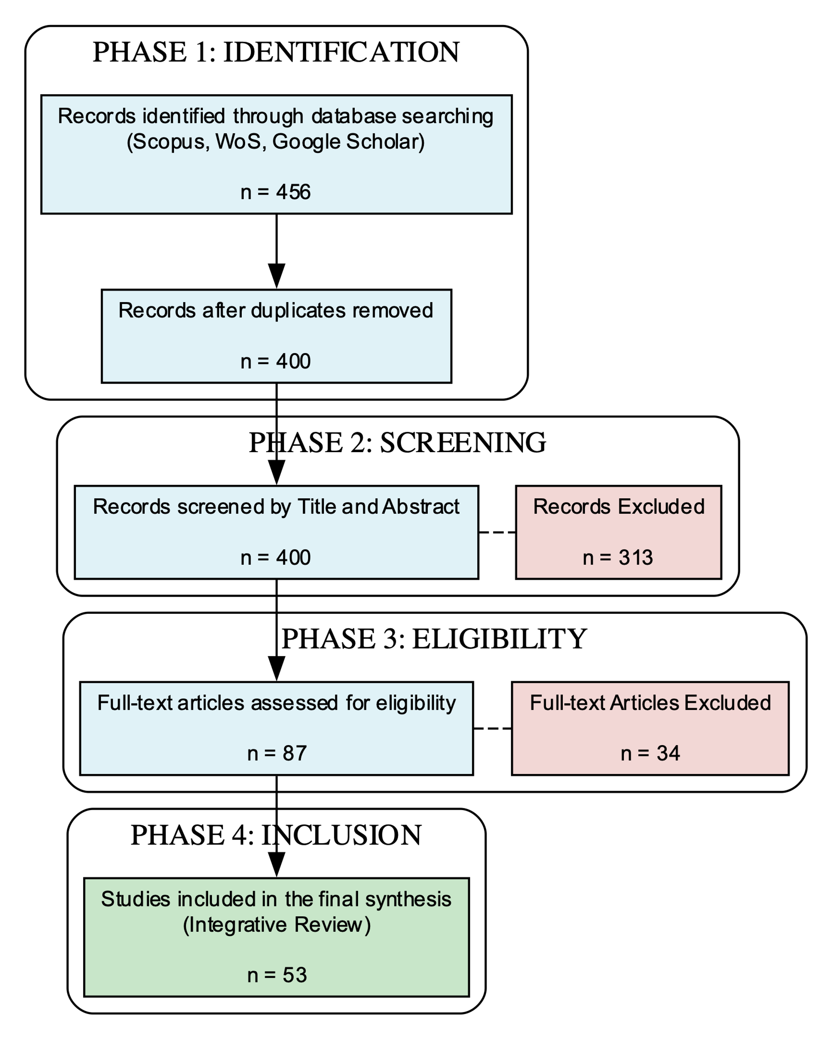
Figure 1. PRISMA Flow Diagram

Data Extraction and Thematic Synthesis
Thematic Analysis was utilized to systematically extract and synthesize the findings and concepts from the 53 selected literature pieces (Braun & Clarke, 2006). Data extraction focused on identifying: (1) challenges in conventional discipline, (2) characteristics of the modern educator, (3) essential practices for Gen Z learners, and (4) theoretical linkages between the concepts. This rigorous synthesis process led to the emergence of four recurring, interconnected patterns.

Conceptual Model Development
The identified patterns were then mapped onto the theoretical underpinnings (Social Cognitive Theory, Self-Determination Theory) to define the four interconnected dimensions (Professional-Adaptive, Pedagogical-Innovative, Relational-Empathetic, and Digital-Ethical), resulting in the final Adaptive Teacher Discipline Conceptual Framework.
RESULTS AND DISCUSSION
Results

The Adaptive Teacher Discipline Model
The main outcome of the systematic Integrative Review of the selected scholarly literature (n=53) is the formulation of the Adaptive Teacher Discipline Model (ATDM). This conceptual model serves as a new theoretical architecture designed to fill the identified gap: the absence of a single, holistic framework that integrates the demands of professionalism, innovative pedagogy, empathetic relationship building, and digital ethics in the disruptive era (Snyder, 2019). The thematic synthesis demonstrates that effective teacher discipline—which ultimately yields Holistic Student Outcomes (cognitive, non-cognitive, and character)—is not merely classroom management, but rather the organic product of four interconnected competency dimensions internalized as a form of professional self-discipline by the teacher. The model is visually presented as an integrated framework in Figure 2, illustrating how the four core dimensions interact and flow from the context of disruptive era challenges toward the desired student outcomes.

Synthesis of Findings and Core Model Dimensions
The ATDM is underpinned by the finding that effective discipline must shift the locus of control from external (student) to internal (teacher), aligning with the principles of Social Cognitive Theory which emphasizes the teacher's behavioral modeling as a primary variable in the student's social environment (Nilsén, 2015; Shafie & Isa, 2021). The four dimensions of the ATDM, synthesized from the literature, are:

Professional-Adaptive

This dimension is the foundation of the teacher's willingness and capacity for change. Discipline starts with the teacher's professional readiness to flexibly modify teaching and classroom management strategies to adjust to technological shifts and diverse student needs. The core of this dimension is a commitment to Continuous Professional Development (CPD) that focuses on enhancing resilience and adaptability.

Pedagogical-Innovative

This dimension links disciplinary practice with relevant learning experiences. Effective discipline is achieved through intrinsic student engagement, not external control. This is realized by:
- Implementing Student-Centered Learning that supports students' need for autonomy and competence (in line with SDT principles) (Deci & Ryan, 2008).
- Applying Differentiated Instruction to accommodate varying readiness levels.
- Utilizing technology frameworks (like TPACK) to ensure instruction remains engaging and relevant.

Relational-Empathetic

This is the psychological and emotional foundation of the model, which directly meets the student's psychological need for relatedness (Hornstra et al., 2023). Relational-Empathetic Discipline requires teachers to use Empathy as an early intervention tool (Berghe et al., 2012), moving beyond sanctions to focus on teaching self-regulation and constructive conflict resolution via Restorative Practices.

Digital-Ethical

This is the most crucial and modern dimension, explicitly extending teacher discipline into the cyber domain. This dimension requires the teacher to not only integrate technology but also to: (a) serve as a role model for ethical technology use; (b) actively teach Digital Citizenship and Media Literacy; and (c) develop proactive strategies for cyberbullying prevention and managing risks in student online interactions (Kasmawati & Naryoto, 2022). In summary, the ATDM is a new synthesis arguing that a productive classroom environment is the natural outcome of the teacher's integrated professional discipline in synergizing these four dimensions, rather than the result of applying isolated external control techniques.

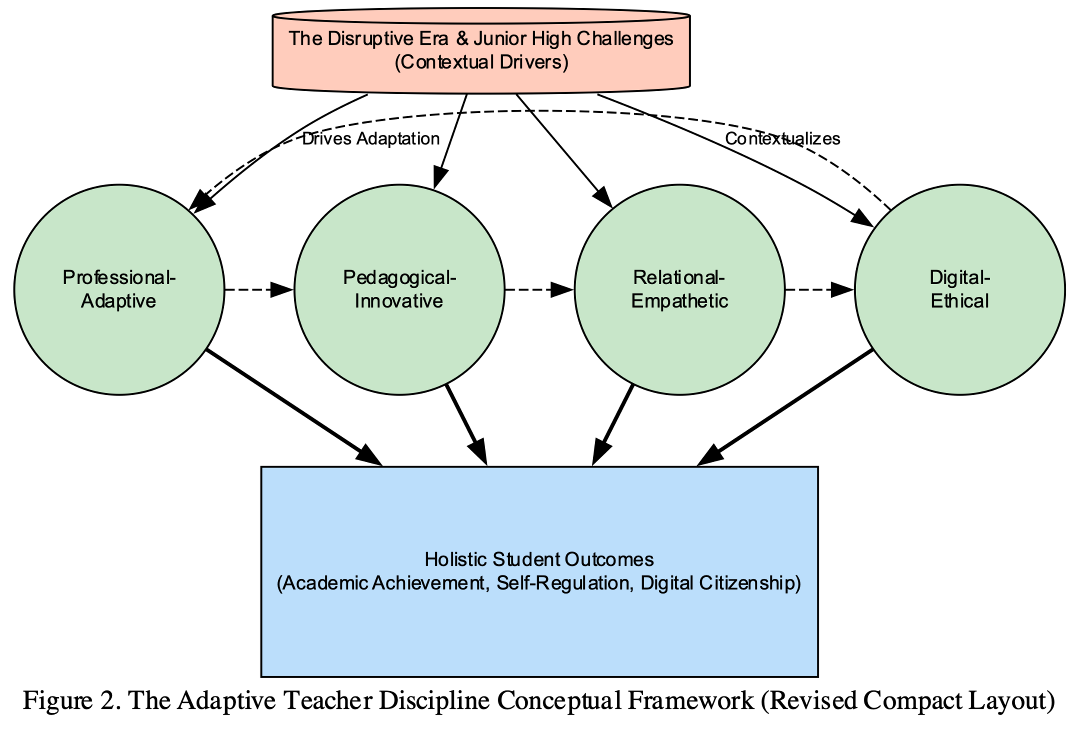

Figure 2. The Adaptive Teacher Discipline Conceptual Framework

DISCUSSION

Theoretical Underpinnings and Model Mechanism
The primary theoretical foundation supporting the Adaptive Teacher Discipline Model (ATDM) is Social Cognitive Theory (SCT), which emphasizes the critical role of observational learning and modeling in shaping behavior (Nilsén, 2015). In the educational context, the teacher serves as the main model in the students' social environment. Every action and attitude displayed by the teacher significantly influences student learning and behavior. The ATDM inherently adopts this principle, arguing that effective discipline originates from the teacher's own professional self-discipline. Its four dimensions—Professional-Adaptive, Pedagogical-Innovative, Relational-Empathetic, and Digital-Ethical—directly reflect how teachers serve as role models for professionalism, effective learning methods, respectful interaction, and digital ethics (Shafie & Isa, 2021).
To explain its motivational mechanism, the model is strongly aligned with Self-Determination Theory (SDT). SDT posits that intrinsic motivation flourishes when students' three basic psychological needs are met: autonomy (a sense of choice), competence (a sense of capability), and relatedness (a sense of connection) (Deci & Ryan, 2008). The Pedagogical-Innovative Dimension is designed to support students' needs for autonomy and competence through student-centered learning and differentiated instruction. The Relational-Empathetic Dimension directly addresses the need for relatedness. When teachers consistently apply practices that support these three needs, students are more likely to engage voluntarily, fostering long-term motivation, achievement, and psychological well-being (Hornstra et al., 2023).
Furthermore, the implementation of the model by individuals requires environmental support, making Transformational Leadership and Ecological Systems Theory relevant. Transformational leadership creates the school culture necessary for sustainable implementation by empowering teachers to innovate. Bronfenbrenner's theory justifies the model's holistic nature: ATDM bridges the microsystem (classroom relations) and mesosystem (school-family relations) through the Relational-Empathetic Dimension, while actively responding to the macrosystem (global digital culture) through the Digital-Ethical Dimension (Berghe et al., 2012).

Critical Comparison and Added Value
When critically compared with established international frameworks, the ATDM offers a significant value proposition by moving beyond traditional behavioral control mechanisms. Classical models such as Assertive Discipline (AD) focus heavily on external control and compliance through consequences (Kasmawati & Naryoto, 2022). While AD provides structure, its external locus of control is insufficient for cultivating the self-regulated citizens required in the 21st century. The ATDM moves beyond AD by shifting the focus from "managing students" to "managing and disciplining the teacher's self", thereby achieving positive behavior as an organic byproduct of the teacher's professional integrity.
Similarly, while Positive Behavior Interventions and Supports (PBIS) is highly proactive in school-wide prevention, its focus often remains on the physical environment and lacks explicit mechanisms for integrating Digital Ethics into its core matrix (Tzoneva, 2023). The most salient added value of the ATDM is the systematic synthesis of four previously disparate domains, providing the first framework to explicitly address the complexities of digital citizenship and cyber-ethics within a cohesive disciplinary model.
The ATDM does not seek to replace, but to integrate and contextualize other essential frameworks like TPACK and 21st-Century Skills. It views TPACK as the technical "engine" within the Pedagogical-Innovative and Digital-Ethical Dimensions, but crucially adds the "why": that is, due to a Professional-Adaptive commitment and grounded in Digital-Ethical responsibility. By integrating elements from classroom management, TPACK, and 21st-Century learning goals into a single, cohesive vision, the ATDM offers a more comprehensive theoretical architecture for the holistically disciplined teacher.

Practical Implications, Limitations, and Future Research

Practical Implications
The ATDM provides clear, actionable guidance for practitioners, particularly relevant for implementing the "Kurikulum Merdeka" (Independent Curriculum):
- Classroom Application (Teachers): Teachers must fundamentally view discipline as a Pedagogical Act to foster student engagement (Pedagogical-Innovative). Behavioral interventions should shift from punishment to Restorative Practices, driven by Relational-Empathetic skills, to teach accountability and self-regulation.
- School Leadership and Policy: School leaders must promote a Professional-Adaptive culture through Continuous Professional Development (CPD) and establish explicit Digital Ethics Policies that guide conduct both online and offline, utilizing Transformational Leadership principles.
- Teacher Development (Training): Teacher training curricula must be reformed to include mandatory modules on Digital Literacy and Ethics, as well as intensive practice in Relational-Empathetic communication and conflict mediation.

Limitations and Future Research
As a purely conceptual study, the ATDM's primary limitation is that its empirical validity remains untested in real-world junior high school settings. Furthermore, its successful implementation is highly dependent on external factors, such as robust institutional support and strong school leadership.
Future research must therefore focus on: (1) Empirical Validation of the model through action research or qualitative case studies to test the ATDM's effectiveness in improving student self-regulation and digital citizenship; (2) Instrument Development to create a validated scale for measuring teacher competence across the ATDM's four dimensions; and (3) Cross-Cultural Comparison to determine if the weight or relevance of these four dimensions requires adjustment in different educational contexts.

CONCLUSION
This research successfully addresses its central questions by formulating the Adaptive Teacher Discipline Model (ATDM), a holistic conceptual framework specifically designed to navigate the complexities of the disruptive era. The most important finding is the confirmation that effective teacher discipline today requires the systematic integration of four essential and interconnected dimensions: Professional-Adaptive, Pedagogical-Innovative, Relational-Empathetic, and Digital-Ethical. This multi-dimensional model provides a comprehensive theoretical answer to how educators can move beyond the limitations of conventional approaches to holistically improve student outcomes in the contemporary educational landscape.
The primary strength and theoretical contribution of this study lie in its integrative and unifying synthesis. Unlike previous scholarly work that tends to examine classroom management, technology integration (e.g., TPACK), or teacher competency in isolation, the ATDM offers a new theoretical architecture that unifies these critical elements into a single, cohesive framework. A key conceptual contribution is the fundamental shift in focus: from simple "techniques for managing students" to the "practice of teacher self-discipline" as the foundational element of an effective learning environment. This provides a novel starting point for future teacher discipline studies.
This new architecture yields significant practical contributions across the educational ecosystem:
- Teacher Development: The ATDM serves as a blueprint for reforming teacher education curricula and Continuous Professional Development (CPD) modules, ensuring that training explicitly includes intensive modules on Digital Ethics and Relational-Empathetic practices, aligning them with the demands of the 21st century.
- School Policy: The model provides clear guidelines for principals to build supportive school cultures and establish explicit Digital Ethics Policies, thereby fostering an adaptive and ethical learning environment for both teachers and students.
This study acknowledges two main limitations. First, as a conceptual model developed through an integrative review, the ATDM is theoretical and has not yet been empirically validated in real classroom settings. Second, while its principles are broadly applicable, the model is specifically contextualized for the Indonesian educational system (Junior High), and its direct application in other cultural contexts may require further adaptation.
These limitations point to crucial directions for future research. The immediate priority is the empirical validation of the ATDM. This requires: (1) Qualitative in-depth case studies to explore the practical manifestation and challenges of the model in classrooms; (2) Quantitative research aimed at developing a validated measurement instrument (scale) to assess each ATDM dimension; and (3) Studies to statistically correlate the four dimensions with specific student learning outcomes and self-regulation skills.

BIBLIOGRAPHY
- Aldrup, K., Carstensen, B., & Klusmann, U. (2022). Is Empathy the Key to Effective Teaching? A Systematic Review of Its Association with Teacher-Student Interactions and Student Outcomes. Educational Psychology Review, 34(3), 1177–1216. https://doi.org/10.1007/s10648-021-09649-y
- Alsem, S. C., Brink, F. v. d., Hoogendijk, K., & Tick, N. T. (2024). Characterizing Teacher‐perceived and Student‐perceived Teacher–student Relationship Types and Associations with Student Functioning in Students With Special Educational Needs: A Cross‐sectional Study Using Latent Profile Analyses. Journal of Research in Special Educational Needs, 25(2), 388–402. https://doi.org/10.1111/1471-3802.12732
- Berghe, L. V. d., Vansteenkiste, M., Cardon, G., Kirk, D., & Haerens, L. (2012). Research on Self-Determination in Physical Education: Key Findings and Proposals for Future Research. Physical Education and Sport Pedagogy, 19(1), 97–121. https://doi.org/10.1080/17408989.2012.732563
- Biantoro, D., & Jasmina, T. (2021). Hubungan Antara Tunjangan Profesi Guru Dan Tambahan Penghasilan Dengan Capaian Pembelajaran Siswa Sekolah Menengah Pertama Negeri. Jurnal Pendidikan Dan Kebudayaan, 6(2), 198–214. https://doi.org/10.24832/jpnk.v6i2.2375
- Braun, V., & Clarke, V. (2006). Using thematic analysis in psychology. Qualitative Research in Psychology, 3(2), 77–101. https://doi.org/10.1191/1478088706qp063oa
- Chen, A., Li, W., & Fu, W. (2024). Unleashing Digital Superheroes: Unravelling the Empathy Factor in Digital Competence and Online Teacher Autonomy Support. British Journal of Educational Technology, 55(4), 1790–1810. https://doi.org/10.1111/bjet.13433
- Chun, Τ. C., & Abdullah, M. N. L. Y. (2022). Contemporary Practices in Teaching 21st Century Skills at Malaysian Primary Schools: Do Environmental Factors and Teacher’s Attitudes Matter? Asia Pacific Journal of Educators and Education, 37(1), 61–85. https://doi.org/10.21315/apjee2022.37.1.4
- Darwisy, I. H., Praherdhiono, H., & Degeng, M. D. K. (2024). Dampak Keterampilan Dan Sikap Guru Sekolah Dasar Pasca Pelatihan Dan Pendampingan Desain Pembelajaran Humanistik. JKTP Jurnal Kajian Teknologi Pendidikan, 7(2), 079. https://doi.org/10.17977/um038v7i22024p079
- Deci, E. L., & Ryan, R. M. (2008). Self-Determination Theory: A Macrotheory of Human Motivation, Development, and Health. Canadian Psychology/Psychologie Canadienne, 49(3), 182–185. https://doi.org/10.1037/a0012801
- Desimone, L. M. (2009). Improving Impact Studies of Teachers’ Professional Development: Toward Better Conceptualizations and Measures. Educational Researcher, 38(3), 181–199. https://doi.org/10.3102/0013189x08331140
- Ge, Y., Li, W., Chen, F., Kayani, S., & Qin, G. (2021). The Theories of the Development of Students: A Factor to Shape Teacher Empathy from the Perspective of Motivation. Frontiers in Psychology, 12. https://doi.org/10.3389/fpsyg.2021.736656
- Göktaş, E., & Kaya, M. (2023). The Effects of Teacher Relationships on Student Academic Achievement: A Second Order Meta-Analysis. Participatory Educational Research, 10(1), 275–289. https://doi.org/10.17275/per.23.15.10.1
- Gondwe, F. (2021). Technology Professional Development for Teacher Educators: A Literature Review and Proposal for Further Research. Sn Social Sciences, 1(8). https://doi.org/10.1007/s43545-021-00184-9
- Hegade, P., & Shettar, A. (2022). Elevate-Z: A Model to Create Learning Spaces for Generation Z Students. Journal of Engineering Education Transformations, 35(S1), 175–180. https://doi.org/10.16920/jeet/2022/v35is1/22025
- Hornstra, L., Stroet, K., Rubie‐Davies, C. M., & Flint, A. (2023). Teacher Expectations and Self-Determination Theory: Considering Convergence and Divergence of Theories. Educational Psychology Review, 35(3). https://doi.org/10.1007/s10648-023-09788-4
- Irwan, I., & Tiara, M. (2022). Penguatan Nilai-Nilai Pancasila Pada Pembelajaran PPKn Dalam Meningkatkan Ketahanan Pribadi Guru Sekolah Menengah Pertama Remote Area Di Kabupaten Kepulauan Mentawai Sumatera Barat. Jurnal Ketahanan Nasional, 27(3), 398. https://doi.org/10.22146/jkn.68636
- Jiang, N., Li, H., Ju, S.-Y., Kong, L.-K., & Li, J. (2025). Pre-Service Teachers’ Empathy and Attitudes Toward Inclusive Education—The Chain Mediating Role of Teaching Motivation and Inclusive Education Efficacy. Plos One, 20(4), e0321066. https://doi.org/10.1371/journal.pone.0321066
- Joko, J., Rachmadio, R. E., & Nugraha, D. (2024). Implementasi Sistem Pembelajaran Efektif Sebagai Strategi Penguatan Profesionalisme Guru Dalam Era Digital. Maju, 1(6), 501–508. https://doi.org/10.62335/7a62w667
- Kasmawati, Y., & Naryoto, P. (2022). Peningkatan Prestasi Siswa Melalui Kompetensi Guru Dan Budaya Kolaboratif. Equilibrium Jurnal Pendidikan, 10(2), 212–220. https://doi.org/10.26618/equilibrium.v10i2.7479
- Keliobas, A. A., Handiyani, H., Afriani, T., & Suryani, C. T. (2021). Kesesuaian Kompetensi Dan Area Kerja Perawat Rawat Jalan. Journal of Telenursing (Joting), 3(2), 699–710. https://doi.org/10.31539/joting.v3i2.2992
- Liu, X. (2024). Effect of Teacher–student Relationship on Academic Engagement: The Mediating Roles of Perceived Social Support and Academic Pressure. Frontiers in Psychology, 15. https://doi.org/10.3389/fpsyg.2024.1331667
- McDonagh, A., Giæver, T. H., Mifsud, L., & Milton, J. (2021). Editorial Introduction—Digital Competence in Teacher Education Across Europe. Nordic Journal of Comparative and International Education (Njcie), 5(4), 1–4. https://doi.org/10.7577/njcie.4604
- Meifauziah, U., & Said, I. (2024). An Analysis of 21st Century EFL Teachers’ Pedagogical Competence Regarding the Digital Era. Journal of English Education Program (Jeep), 11(1), 85. https://doi.org/10.25157/(jeep).v11i1.13564
- Mulyana, M., Wicaksono, L., Junanto, T., & Millah, R. (2023). Kompetensi Penulisan Karya Ilmiah Guru Dalam Perspektif Agil. Manajemen Pendidikan, 18(2), 84–98. https://doi.org/10.23917/jmp.v18i2.23283
- Nilsén, P. (2015). Making Sense of Implementation Theories, Models and Frameworks. Implementation Science, 10(1). https://doi.org/10.1186/s13012-015-0242-0
- Page, M. J., McKenzie, J. E., Bossuyt, P. M., Boutron, I., Hoffmann, T. C., Mulrow, C. D., Shamseer, L., Tetzlaff, J. M., Akl, E. A., Brennan, S. E., Chou, R., Glanville, J., Grimshaw, J. M., Hróbjartsson, A., Lalu, M. M., Li, T., Loder, E. W., Mayo-Wilson, E., McDonald, S., … Moher, D. (2021). The PRISMA 2020 Statement: An Updated Guideline for Reporting Systematic Reviews. BMJ, 372, n71. https://doi.org/10.1136/bmj.n71
- Pavlíčková, R., Škrabal, J., & Poledna, M. (2024). Interaktivní Vzdělávání Generace Z. MNK. https://doi.org/10.61544/mnk/qdkm7795
- Prasetyarini, A., Hikmat, M. H., & Thoyibi, M. (2021). Strategies to Cope with Students’ Discipline Problems in Senior High School. Indonesian Journal on Learning and Advanced Education (Ijolae), 40–47. https://doi.org/10.23917/ijolae.v3i1.9474
- Reistanti, A. P., Irchamni, A., Permatasari, K. G., & Sule, M. M. (2025). 21st Century Teachers in the Perspective of Modern and Islamic Education: Answering the Challenges of the Digital Era and Globalization. Pedagogy, 18(1), 35–44. https://doi.org/10.63889/pedagogy.v18i1.250
- Sari, P. R., Ichsanti, D. F., Alwatasi, U., Astuti, R. T., & Husna, D. (2023). Pengembangan Keprofesian Berkelanjutan: Sebagai Upaya Meningkatkan Teacher Profesionality. Masaliq, 3(5), 941–950. https://doi.org/10.58578/masaliq.v3i5.1513
- Shafie, D. I., & Isa, S. M. (2021). Entrepreneur Resilience: How Do Entrepreneurial Self-Efficacy and Basic Psychological Needs Influence It? The Effect of COVID-19 on Malaysia’s Small and Medium Enterprises. Jurnal Intelek, 16(2), 1–10. https://doi.org/10.24191/ji.v16i2.388
- Sierto, M. E. (2023). The Science Teachers’ Communication Behavior in Relation to Students’ Attitude and Performance. International Journal of Multidisciplinary Applied Business and Education Research, 4(9), 3386–3302. https://doi.org/10.11594/ijmaber.04.09.18
- Snyder, H. (2019). Literature review as a research methodology: An overview and guidelines. Journal of Business Research, 104, 333–339. https://doi.org/10.1016/j.jbusres.2019.07.039
- Tzoneva, I. (2023). Benefits and Challenges in Using Ai-Powered Educational Tools. https://doi.org/10.36315/2023v2end079
- Wang, C., Xu, Q., & Fei, W. (2024). The Effect of Student-Perceived Teacher Support on Math Anxiety: Chain Mediation of Teacher–student Relationship and Math Self-Efficacy. Frontiers in Psychology, 15. https://doi.org/10.3389/fpsyg.2024.1333012
- Waton, M. N. (2023). Relevansi Perubahan Kurikulum 2013 Terhadap Kurikulum Merdeka Belajar Di Era Digital. Muróbbî Jurnal Ilmu Pendidikan, 7(1), 129–146. https://doi.org/10.52431/murobbi.v7i1.1631
- Whittemore, R., & Knafl, K. (2005). The Integrative Review: Updated Methodology. Journal of Advanced Nursing, 52(5), 546–553. https://doi.org/10.1111/j.1365-2648.2005.03621
- Zhou, G., & Eslami, Z. R. (2023). EFL Teachers’ Perceptions of the Challenges of Technology-Based Professional Development. Porta Linguarum Revista Interuniversitaria De Didáctica De Las Lenguas Extranjeras. https://doi.org/10.30827/portalin.vi2023c.29627

